

**BCS2313 ARTIFICAL INTELLIGENCE TECHNIQUE**

**SEMESTER Il SESSION 2016/2017**

**ASSIGNMENT 2**

**PREPARED FOR:**

**SIR SAHLI**

**PREPARED BY:**

|  |  |
| --- | --- |
| **NAME** | **MATRIC NO** |
| **AHMAD SOLEHIN BIN SHARUDDIN** | **CB15003** |

coding

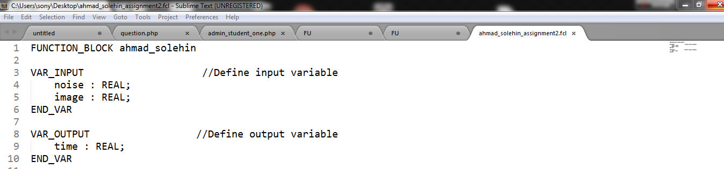

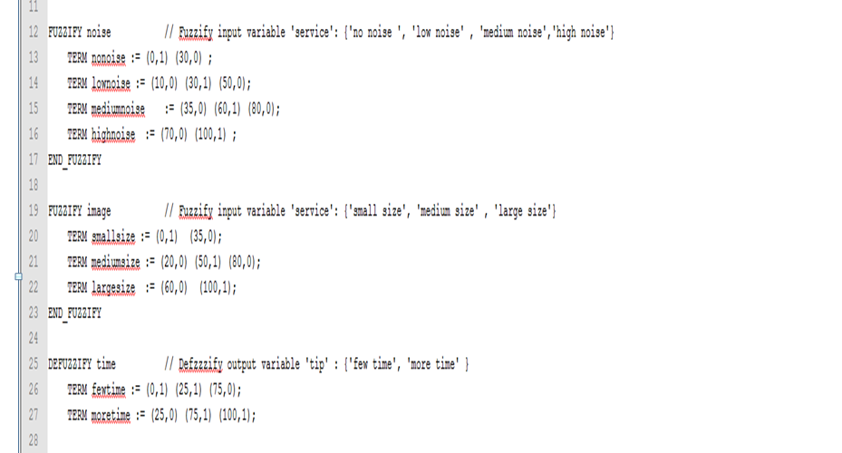

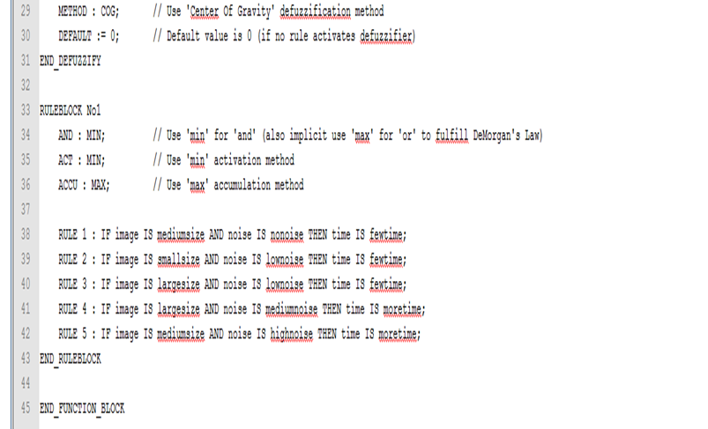

Output

